The Learning Disability and Autism Team Strategy 2025 to 2028
Thinking about the last time you came to hospital, how was it?

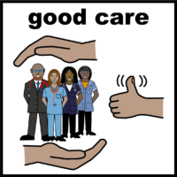 | What went well?
 | What could have been better?
 | Do you have any ideas about how to improve the hospital?

